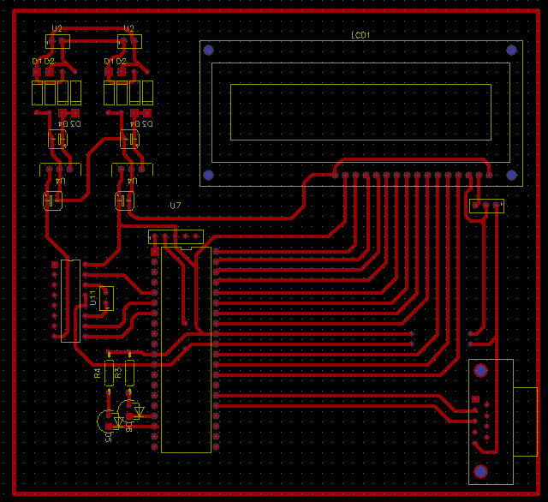

RFID BASED SECURITY SYSTEM